TASK 1:
let itemPrice = 450.0
let quantity = 3
// Subtotal
let subtotal = itemPrice * Double(quantity)
// Discount
let hasCoupon = true
let discount = (hasCoupon && subtotal > 1000) ? subtotal * 0.1 : 0.0
// GST and total
let gst = (subtotal - discount) * 0.18
let total = subtotal - discount + gst
// Bill per person
print("Total:", total)
print("Each person:", total / 4)
// Hundreds and remainder
let amount = 1234
print("Hundreds:", amount / 100)
print("Remainder:", amount % 100)

OUTPUT:
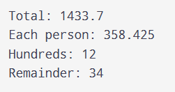

TASK 2:
// Leap year
for year in [1900, 2000, 2024, 2026] {
let leap = (year % 4 == 0 && year % 100 != 0) || year % 400 == 0
print(year, leap)
}

// Number between 1 and 100
let number = 50
print((1...100).contains(number))

// Even and not a multiple of 10
print(number % 2 == 0 && number % 10 != 0)
// Nickname or Guest
let nickname: String? = nil
print(nickname ?? "Guest")

OUTPUT:
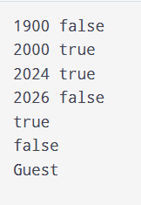

TASK 3:
print(7 / 2) // 3
print(7 % 2) // 1
print(-7 % 3) // -1
print(7.0 / 2) // 3.5
print(10 - 2 * 3 + 4 / 2) // 6
print(5 > 3 && 2 > 4 || true) // true
print(1 << 3) // 8
print(6 & 3, 6 | 3, 6 ^ 3) // 2 6 5

let x: UInt8 = 255
print(x &+ 1) // 0

